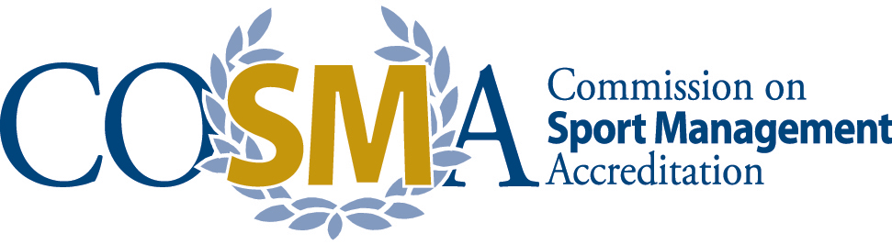

*“COSMA: Advancing Excellence in Sport Management Education”*

Quick Facts

COSMA:

* Recognizes sport management programs that meet professional standards.
* Promotes and recognizes excellence in sport management education in colleges and universities.
* Provides external accountability by keeping programs on the leading edge of trends in higher education.
* Grants a seal of approval on the quality of accredited sport management programs.
* Provides reputation assurance to accredited sport management programs.
* Provides an effective mechanism for continuous improvement in sport management programs.

Institutions, students, employers, and the general public   
all benefit from the external verification of quality   
provided through COSMA’s accreditation process.

For More Information Contact:

|  |  |
| --- | --- |
| COSMA  418 N GRANADA STREET  ARLINGTON, VA 22203  202-329-1189  [WWW.COSMAWEB.ORG](http://WWW.COSMAWEB.ORG)  COSMA@COSMAWEB.ORG |  |

*[](https://www.facebook.com/theCOSMA/?ref=aymt_homepage_panel)[](https://twitter.com/cosmaweb)*

**The Sport Industry: Fact Sheet**

*Today’s global sports industry is worth between* ***$600 and $700 billion****, according to a recent A.T. Kearney study of sports teams, leagues and federations. This includes infrastructure construction, sporting goods, licensed products and live sports events.*

<http://www.careerbuilder.com/share/aboutus/pressreleasesdetail.aspx?sd=8/28/2014&siteid=cbpr&sc_cmp1=cb_pr839_&id=pr839&ed=12/31/2014>

Quick Facts:

* Global sport industry growth: 7%/ year between 2009-2013 (growing faster than the global GDP)
* Top 7 grossing professional sports in the world: Soccer (football), American football, baseball, Formula 1 racing, basketball, hockey, and tennis
* Sporting event business: $80 billion industry
* Sporting goods and licensed products: $310 billion industry
* Fitness industry: $105 billion
* Other areas, including infrastructure construction, food and beverage and betting: $100-$200 billion industry

The Job Outlook:

* The Spectator Sport industry employs approximately 135,000 employees in the US with a median annual income of $42,500
* The Fitness and Recreational Centers Industry employs approximately 533,000 employees in the US with a median annual income of $32,860 and an 8-10% increase of jobs in the next ten years
* The Coaching and Scouting employs approximately 250,000 employees in the US with a median annual income of $32,640 and a 6% increase of jobs in the next 10 years

